Q1:

INCLUDE Irvine32.inc

.data

displayMSG BYTE "Generating 20 random integers between 0 and 990: "

a BYTE 1

b BYTE 1

.code

main PROC

call clrscr

mov ecx,20

mov eax,black+(green\*16)

call SETTEXTcolor

mov edx,OFFSET displayMSG

call writestring

call Randomize

L1:

mov eax,5

call delay

mov dl,b

mov dh,a

call GOTOXY

mov eax,990

call Randomrange

call writedec

call crlf

inc a

inc b

LOOP L1

exit

main ENDP

END main

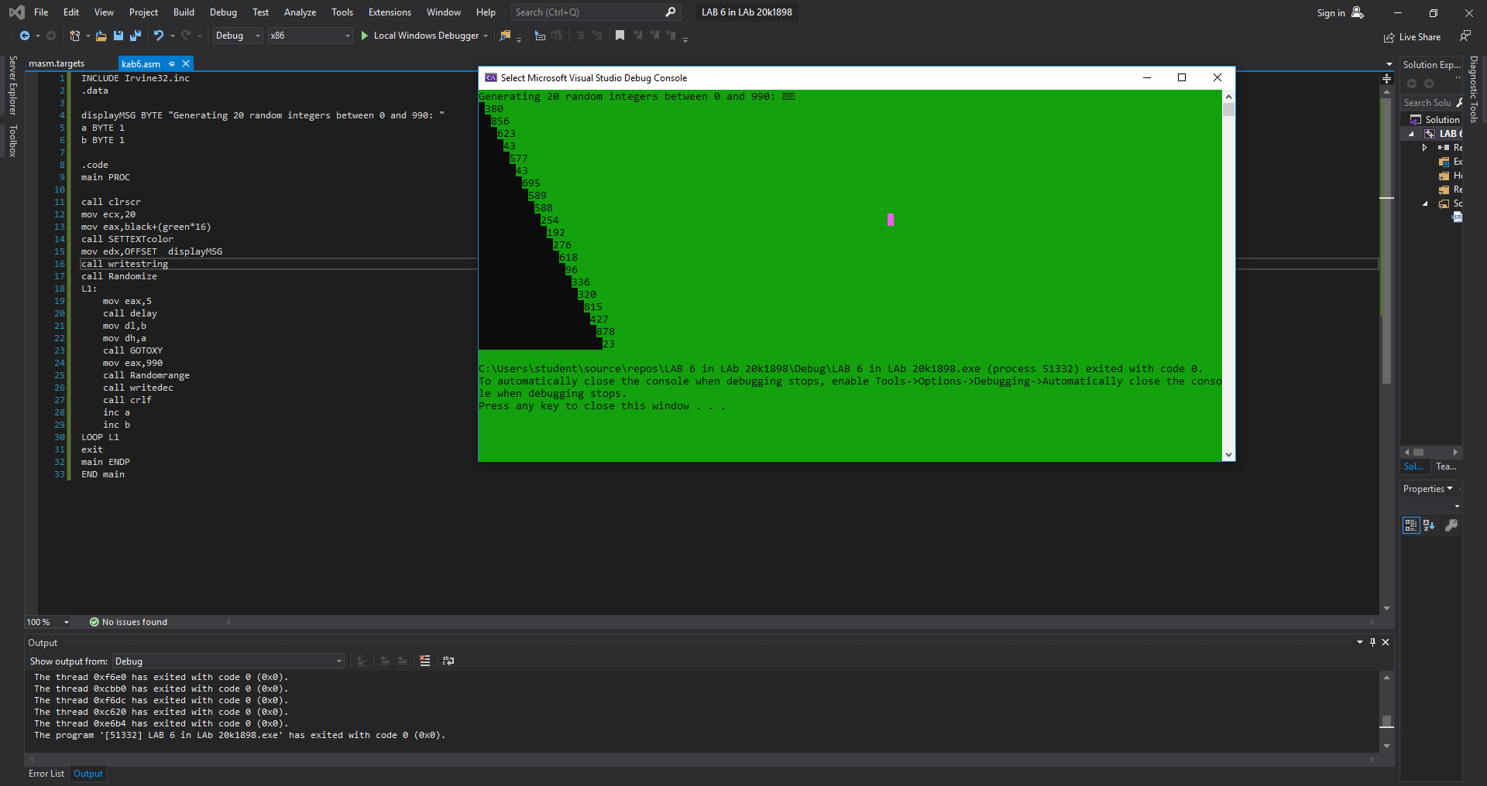

Q2: